**ECO-602 Software Setup**

Screenshot 1: OneDrive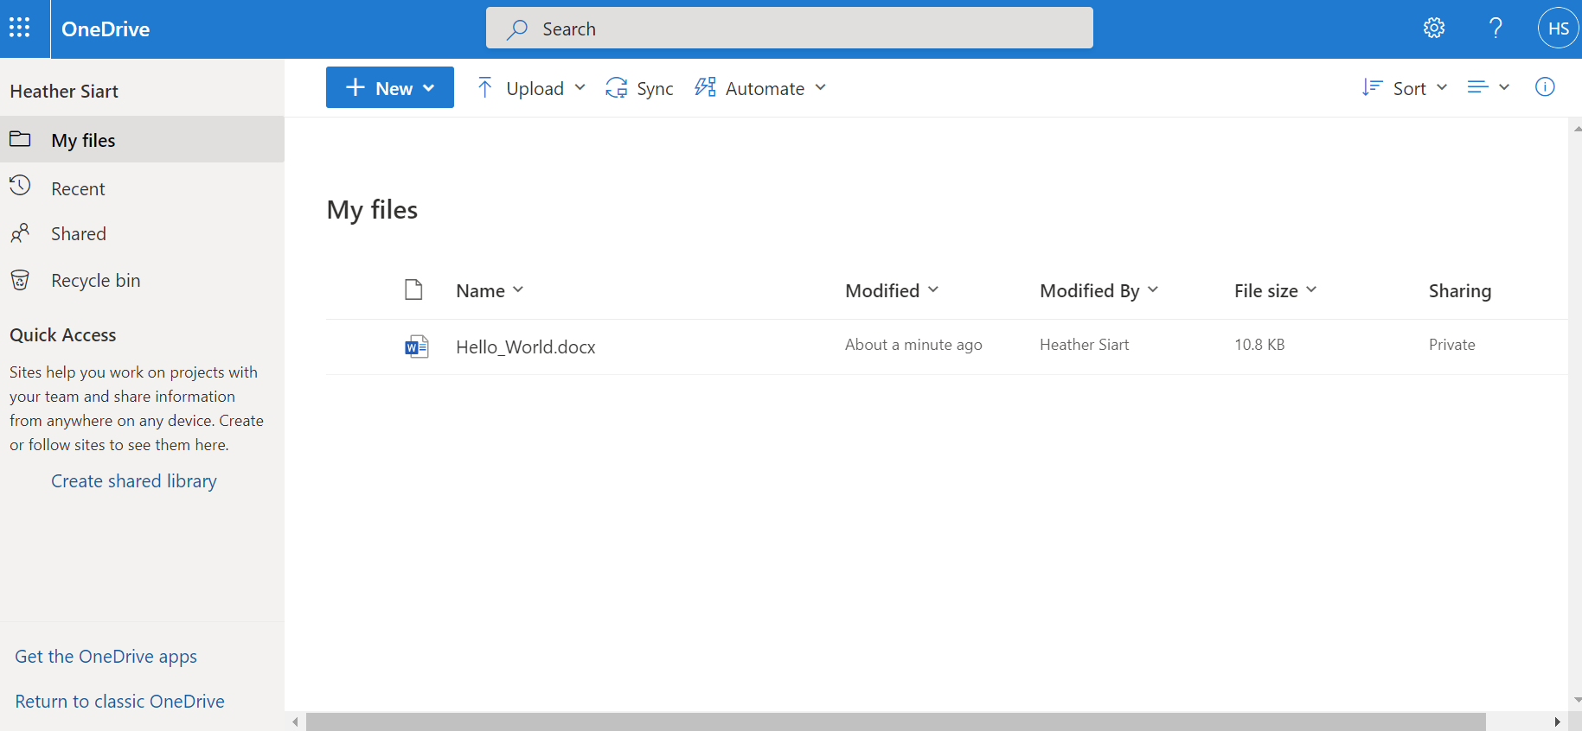

Screenshot 2: Azure Virtual Desktop

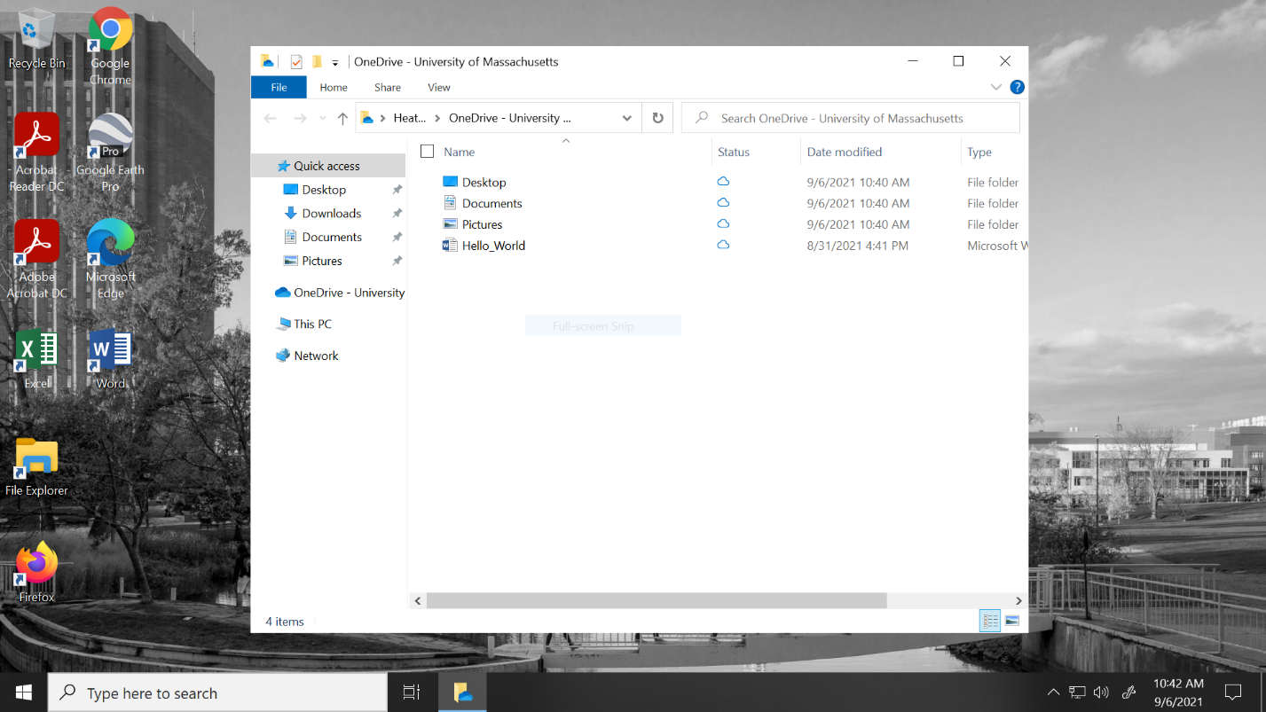

Screenshot 3: RStudio Session with hello_world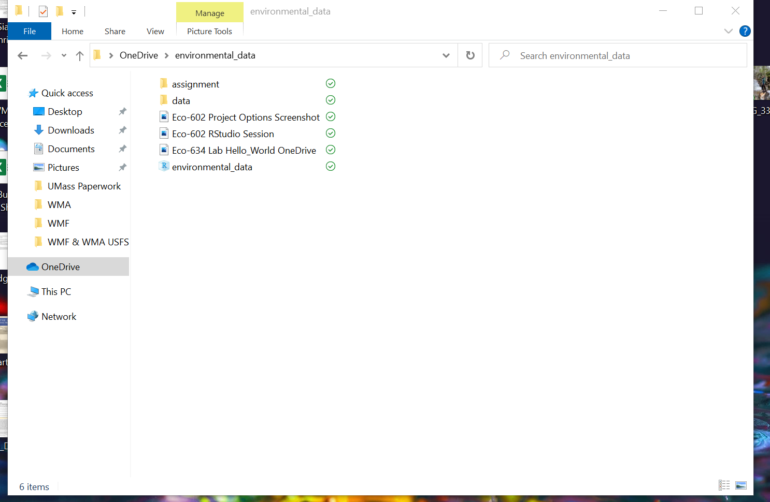

Screenshot 4: Course FolderGraphical user interface, text, application, Word

Description automatically generated

Screenshot 5: RProject with Correct Project Options

